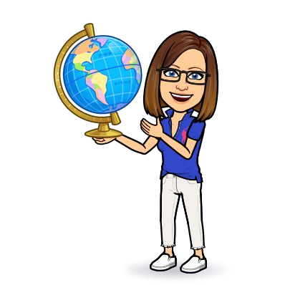
Mrs. Holodick’s Sixth Grade Social Studies
. . . . . . .
Classroom
Cell Phones/Ear Buds

Cell Phones/Ear Buds etc. are to be either turned off or put on silent while in school. Please refer to WVW handbook. Students who choose to bring electronics to class will place the silenced device(s) in their assigned holder when they enter the room and they will remain there until the end of the class period.

1st Offense: Warning/Teachers Desk
2nd Offense: Written Referral and phone call home. Device to office.

Refusal: Automatic written referral and phone call home for insubordination.
About Me
I am starting my 29th year in education and 24th year at WVW. I am married and have two step children. In my spare time I enjoy reading, shopping, photography, traveling adventures and spending time with family. I am an avid sports fan “Go Yankees”. I am excited to begin another school year and look forward to working with your son/daughter.
Contact Information

Teacher: Mrs. Holodick
Email: tholodick@wvwsd.org

You can also message me though Skyward and Remind.
Supplies

Necessary Supplies
- Pencil/Pen
- Crayons/
Colored Pencils
- District Issued Chromebook (Charged)

Optional Supplies
- Post It Notes
- Highlighter
- Loose Leaf Paper
- Planner/
Calendar
- Folder to take materials home
Google Classroom/Skyward/Classroom Website

Google Classroom: Daily agenda as well as classwork and materials are posted on a daily basis.

Skyward: Important dates, announcements and assignments will be posted in Skyward. Parents and students have access to check Skyward and are encouraged to do so. Grades are posted in Skyward in a timely manner so that parents and students are always aware of progress.

Classroom Website: mrsholodick.educatorpages.com
Our classroom website is a valuable tool and contains important information for students to use both in and out of the classroom.
Classroom Supplies
(If you wish to donate to the classroom, anything would be appreciated.)
- Tissues
- Hand Sanitizer
- Clorox Wipes
- Paper Towels
- Lysol
This Photo by Unknown Author is licensed under CC BY-NC

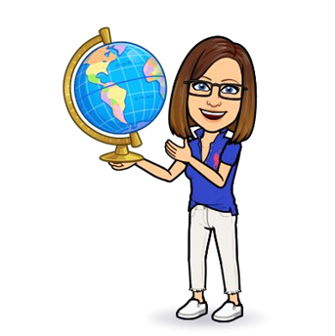
Daily Participation/Classwork Expectations
Daily participation and classwork are a crucial component to our daily lessons. See below for a list of expectations I have for you in order for you to be successful.
- All material needed for class should be brought to class EVERYDAY. i.e. Pen/Pencil, Folder, Crayons/Colored Pencils, Chromebook (Charged)
- Volunteer to read, answer/ask questions, and complete to the best of your ability any assignments/classwork for that day. Become an active learner and get involved in class.
- Follow behavior expectations. Regardless of where you are learning/working: in our classroom with me, a substitute, in the auditorium, or at home, you are expected to behave and follow our behavior expectations.
- You will have until the end of the quarter to complete and submit any missing assignments.

Homework
Written homework is rarely assigned for this class.

Students should be spending at least 10 minutes nightly reviewing material discussed in class, vocabulary or study guides.

Please Remember that if you need help, are struggling or have questions, see me ASAP. Do not wait.
Behavior Expectations

- Be Respectful
- Be Responsible
- Be Kind
- Be Your Best

Grading Information
Students grades will come from a variety of sources each worth 20% of grade:
- Test
- Quiz (There will be a quiz at the end of each section.)
- Projects (Projects are completed in class.)
- Bell Ringer (Daily warm up that will be completed in class.)
- Class Work (Maps, Guided Reading Questions, Worksheets etc.)
Please note that you have access to grades in Skyward on a daily basis.
I do not give grades, students earn them.
Skyward is the best way to see your grades, do so regularly.
Curriculum
This will be an exciting year where we will extend our current knowledge and will get to try new things in our classroom. We will focus on past events in history as well as current events. We will also study the geography of civilizations discussed during the year. The following are the ancient civilizations we will focus on the first quarter: The Beginnings of Human Society (Prehistory-2500 B.C.), The Fertile Crescent (3500B.C.-A.D. 300), Ancient Egypt and Nubia (3100 B.C.-31 B.C.)

This Photo by Unknown Author is licensed under CC BY
Students will be provided with extra credit assignments as long as all other assignments are submitted. Extra credit assignments are posted on our classroom website. These are the only extra credit assignments that will be accepted. The due dates, directions and materials are posted on our classroom website.
Extra Credit

During the first week of school, all procedures and expectations will be covered in class.

Sixth Grade Social Studies: Mrs. Holodick

Parent/Guardian Sheet
Please complete the following and return to school with your son/daughter.
Keep the previous sheets for reference.

Child’s Name: ______________________________________________________________________________
Parent/Guardian Name(s): __________________________________________________________________

Contact
How do you prefer to be contacted and please provide the contact information:
Name:
Best way(s) to contact parents/guardian:
Phone Email
Phone Number__________________ Email Address______________________________

In order for your child to succeed it is important that we work together. Keeping informed about your child’s day will help you to be aware of what is going on. Please refer to Skyward to check for assignments, due dates and any other information necessary. Skyward also allows you to check your child’s progress (grades) throughout the school year.

As the parent/Guardian you know your child the best. Is there anything that you think is important as your child’s teacher that I should know about. (Please use the back if more room is needed.)

Please sign below to indicate that you have read and reviewed the class expectations and overview in this syllabus for Mrs. Holodick’s Social Studies Class.

Student Name: ___________________________________________________________

Student Signature: ________________________________________________________

Parent/Guardian Name: ___________________________________________________

Parent/Guardian Signature: ________________________________________________

Only two pages were converted.
Please Sign Up to convert the full document.

www.freepdfconvert.com/membership

